STANDING ORDER FORM

To set up a standing order, please send this form along with the donation form on the opposite side to the address on the front of the booklet.

DO NOT SEND EITHER TO YOUR BANK

Your bank/building society

Name of bank:

Address:

Request to begin regular payments TO:
Bank: Metro Bank, Epsom

Account Name: Age Concern Epsom & Ewell Account no: 13933286

Sort Code: 23-05-80 Reference no: YOUR NAME
Your name: ____________________________
Amount: ____________________________

Date of first payment: __________________
Frequency of payment: _________________

Monthly/Annually (delete as appropriate)
Date of final payment: UNTIL FURTHER NOTICE

Name of Account to be debited: _______________________

Account No: ____________________________

Sort Code: ____________________________

Signature: ____________________________ Date:________

SUPPORT US BY BECOMING A FRIEND OF ACEE

Our Friends come from many walks of life; clients and their families, carers, volunteers and people throughout the community and beyond who appreciate what we do.

Now, more than ever, the importance of raising funds is paramount to help improve the services for our clients now and in the future.

The generosity of our supporters enables us to fund essential services to empower older people in the borough.

We want as many people as possible to receive the benefits of our services and need as many people as possible to support our work.

With you on board, we can be stronger than ever.

“Little by little,
a little becomes a lot”

HELP US HELP OTHERS
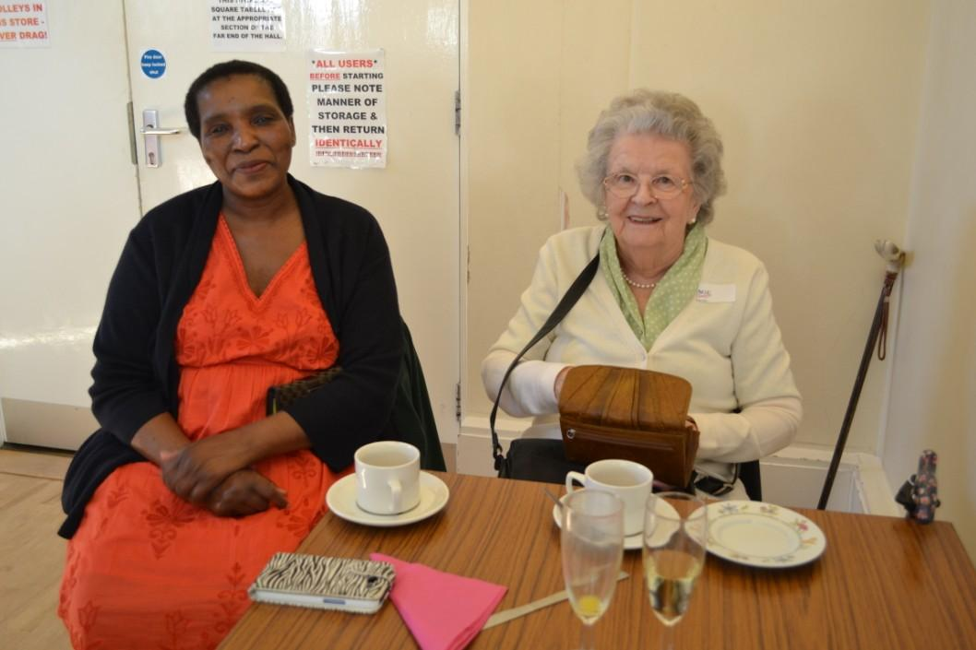

The Old Town Hall

The Parade,

Epsom,

Surrey,

KT18 5AG

Send this to Age Concern Epsom & Ewell, NOT to your bank

01372 732456 info@ageconcernepsom.org.uk

In Epsom & Ewell each week, 1 in 5 people aged over 65 don’t know who to turn to.

Some need advice or help with transport, for some it’s practical help, and for others it’s an opportunity to make friends. Since 1947,

Age Concern Epsom & Ewell has been empowering older people in Epsom & Ewell to live the most fulfilling lives they can.

Next week we know more people will need our help, and we must be there for them too.

Each week the Age Concern Epsom & Ewell staff and volunteers:

- Spend quality time with 70 people

- Drive 270 miles taking people to appointments

- Cut 420 toenails

- Give advice to 94 people

- Help people claim £7,500 of attendance allowance

It costs £1.75 a minute to keep us going

Can you spare us a few minutes?

You can donate in THREE ways ....

- If you wish to contribute monthly we recommend a minimum of £5 each month but the amount is up to you. Please give as much or as little as suits you by Standing Order.

- If you would like the opportunity to win cash prizes but still support us then join our 300 Club. For only £4 per month you will go into our monthly draw to win a cash prize.

- Would you like to support our work Annually? Become a Friend and make a regular annual donation by Standing order (suggested minimum is £20) but please donate as much or as little as suits you.
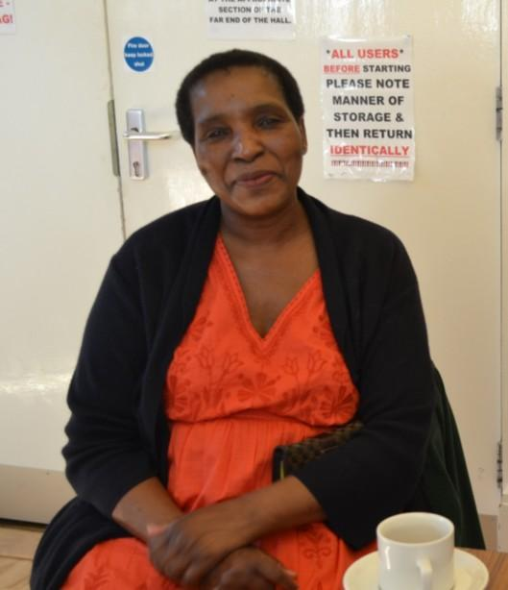
THANK YOU

DONATION FORM
Name: _____________________________________

Address:

Telephone: _________________________________

E-mail: _________________________________

I would like to join the

Monthly (Min £5 each month)

300 Club (£4 per month)

Annually (£20 a year)

Or
I enclose a gift of £

I enclose a cheque/postal order/charity voucher

(payable to ‘Age Concern Epsom & Ewell’)

I enclose a standing order form to set up a
regular payment

Signature: _________________________________

Date: _________________________________
Gift Aid (do you pay tax? Signing below increases your gift

28% at no cost to you)
I would like Age Concern Epsom & Ewell to reclaim the tax from Inland Revenue on:

This donation only

All donations I make for Age Concern Epsom & Ewell

All donations I have made for Age Concern Epsom
& Ewell in last six years

Signature: ________________________ Date: _____________

