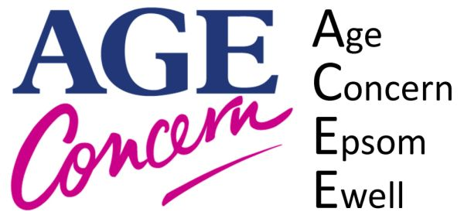

Gift Aid declaration for past, present and future donations to Age Concern Epsom & Ewell Reg Charity Number 1139652

Please treat as Gift Aid donations all qualifying gifts of money made
Today In the past 4 years In the future
Please tick all boxes you wish to apply
I confirm I have paid or will pay an amount of Income Tax and/or Capital Gains Tax for each tax year (6 April to 5 April) that is at least equal to the amount of tax that all the charities or Community Amateur Sports Clubs (CASCs) that I donate to will reclaim on my gifts for that tax year. I understand that other taxes such as VAT and Council Tax do not qualify. I understand the charity will reclaim 25p of tax on every £1 that I give.

DONOR DETAILS
Title
First Name
Surname
Full Address
Postcode
Telephone Number
Date
Signature

Please notify us if you:
- Want to cancel this declaration
- Change your name or home address
- No longer pay sufficient tax on your income and/or capital gains.

If you pay Income Tax at the higher or additional rate and want to receive the additional tax relief due to you, you must include all your Gift Aid donations on your Self Assessment tax return or ask HM Revenue and Customs to adjust your tax code.

